# Steps for setting up Visual Studio and Adding QT extensions:

**Installing The Visual Studio 2022**

Link:

[Https://Visualstudio.Microsoft.Com/Thank-You-Downloading-Visual-Studio/?Sku=Community&Channel=Release&Version=Vs2022&Source=Vslandingpage&Cid=2030&Passive=False](https://visualstudio.microsoft.com/thank-you-downloading-visual-studio/?sku=Community&channel=Release&version=VS2022&source=VSLandingPage&cid=2030&passive=false)

Necessary: Development Kit For C

(1) Available When The Installer Is Launched.

(2) If Only The Bare Minimum Version Is Installed Which Is Approx Around 1.5 Gb – 2.55 Gb , Then We Have To Again Launch The Installer And Go For Modify Option , Then Further Add The Same Developmet Kit For C.

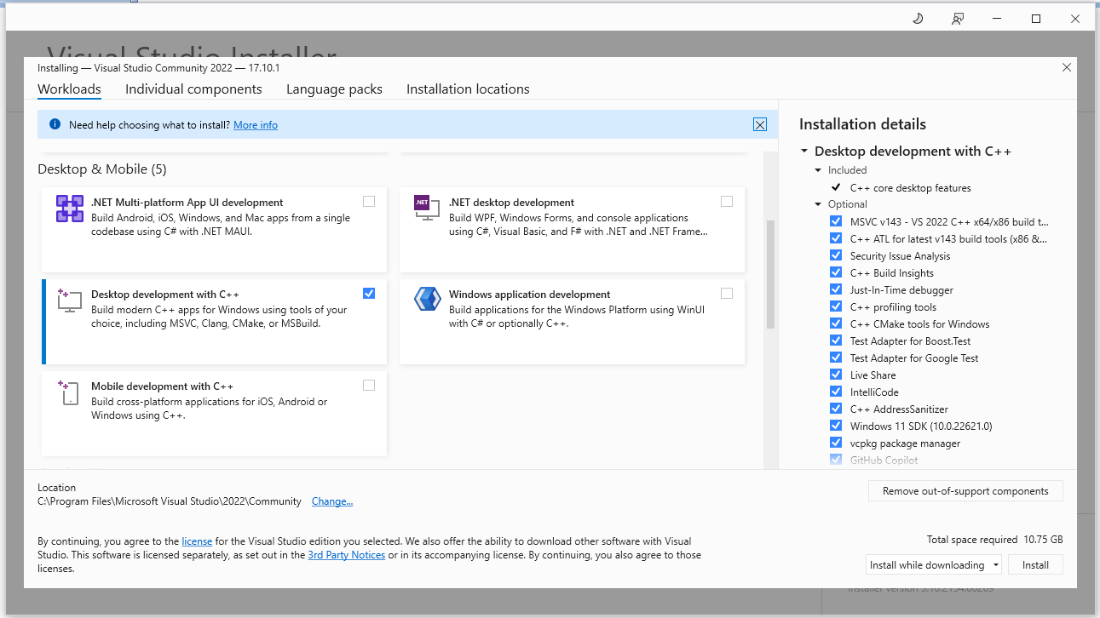

Important:

While Adding The Development Kit Ensure To Checkout The options marked in the Red box.

**Installing Qt:**

1. For installing Qt download the latest release from the official website:

Link: <https://www.qt.io/download>

1. When you launch the .exe of Qt after download is finished a new window will open up.

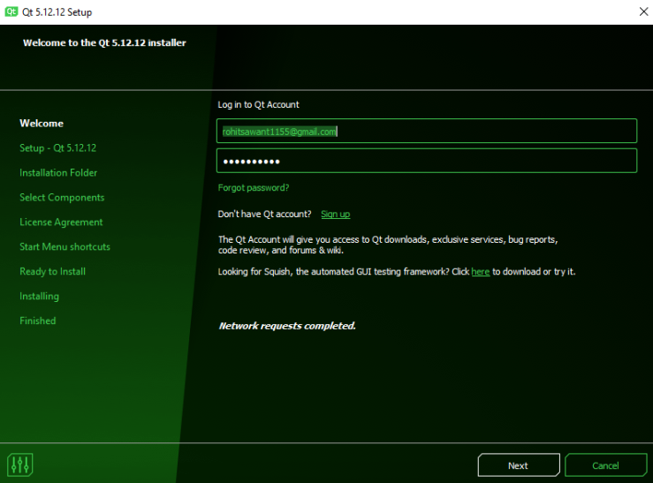

1. If you do not have Qt Account you would have to create one , by clicking on “Sign Up”(The sign process also includes the email verification step , so make you have access to your email account as well)
2. Once account creation successful, then log in the account by entering proper credentials in the above .exe window of Qt.
3. After that fill up the check boxes.

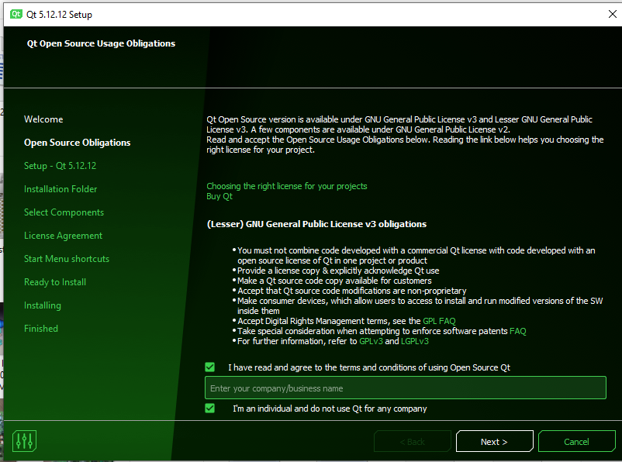

1. Then click on “Next”.

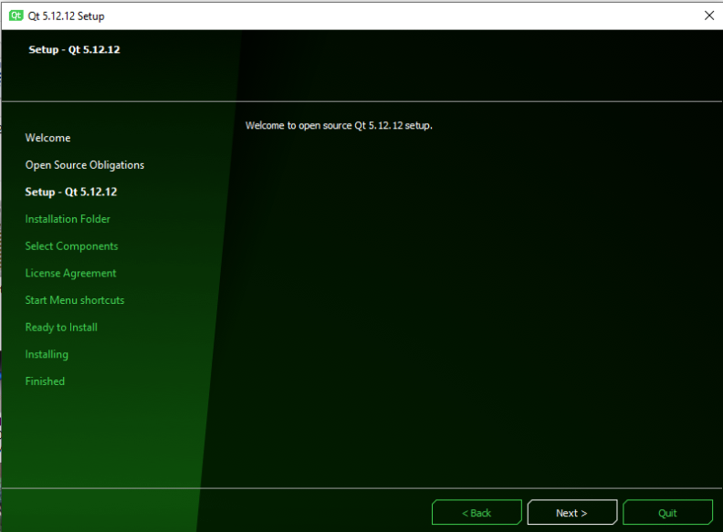

Mirror error such as the following image :

Steps :

1. command prompt run as administrator .

2. Enter clear cache command

1. del /s /q /f %TEMP%\*
2. del /s /q /f "%LOCALAPPDATA%\Microsoft\Windows\Temporary Internet Files\*.*"
3. del /s /q /f "%LOCALAPPDATA%\Packages\Microsoft.MicrosoftEdge_8wekyb3d8bbwe\AC\MicrosoftEdge\Cache\*.*"
4. ipconfig /flushdns
5. del /s /q /f "%LOCALAPPDATA%\Microsoft\Windows\Explorer\thumbcache_*.db"

3. cd /d “path “

4. start qt-online-installer-windows-x64-4.8.0 --mirror http://qt.mirror.constant.com

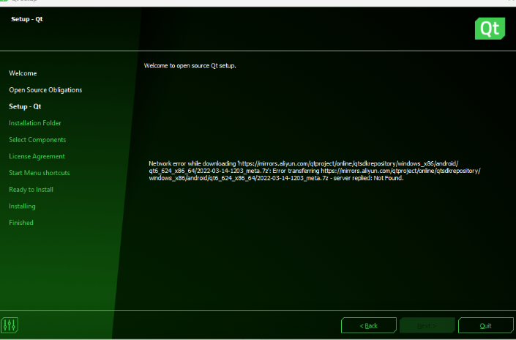

1. Then select the directory where you want to install and click on “Next”.

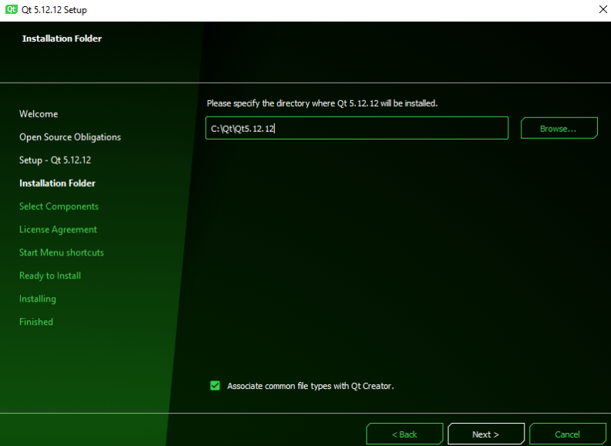

1. Then Select Components which you want to add. In our case, the ones marked in the red are sufficient.

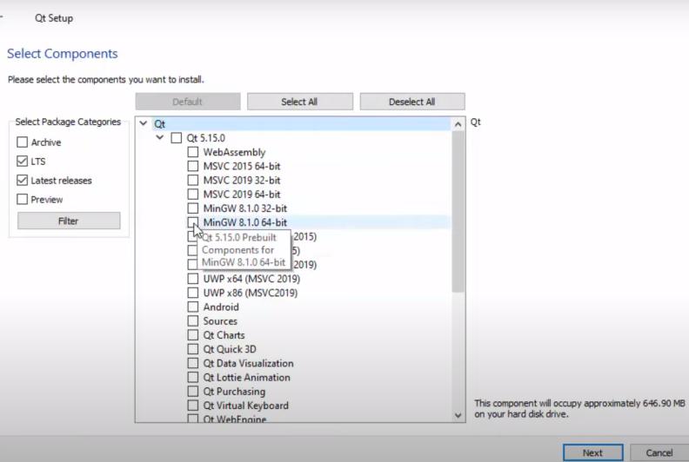

1. Then checkout the following option in the next window.

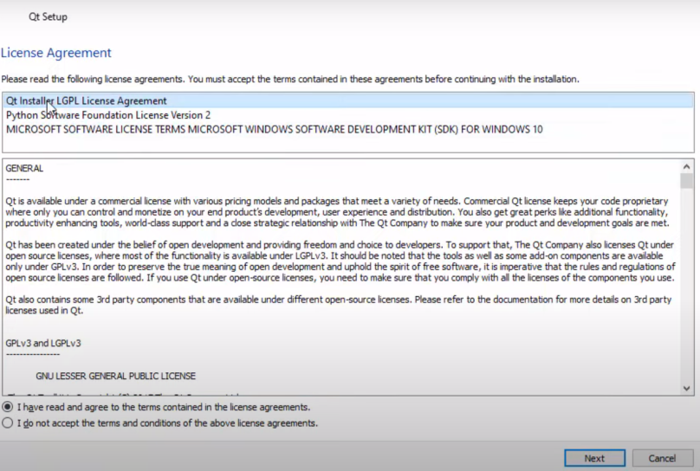

1. Then a new window will appear asking for the Permission for installing the Qt, click on “Yes” to continue.

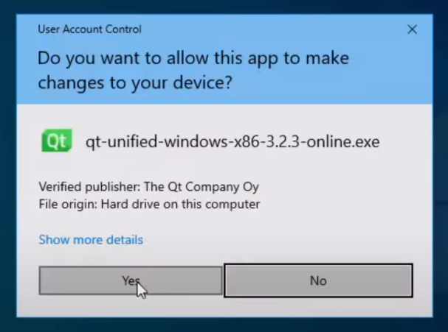

1. Then click on “Install”, the installation process will start.

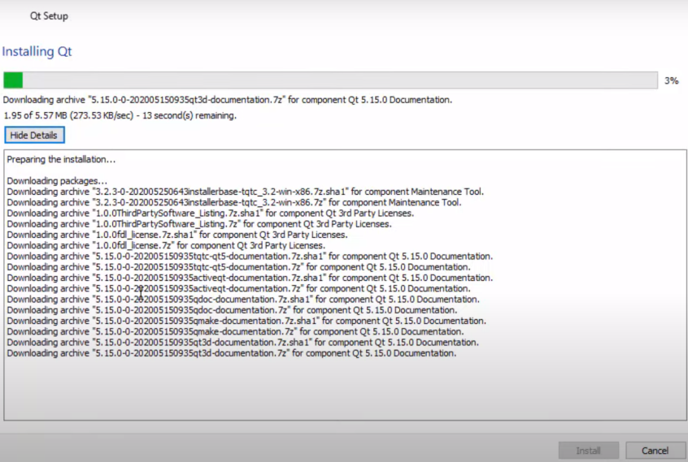

After the installation is complete , follow the next procedure.

**Setting up QT extension in VS:**

1. Launch VS
2. Open “Manage Extensions” and select the “Qt Visual Studio Tools” and download it:

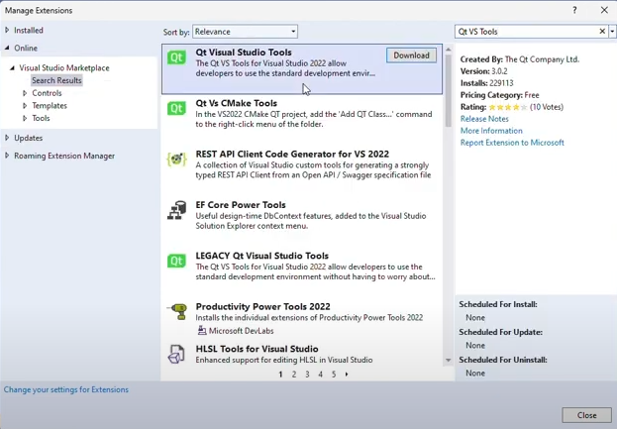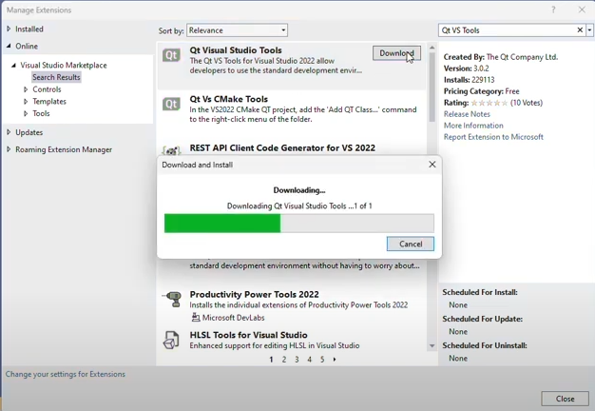

1. In the “Manage Extensions” itself, search for “QML Syntax/Tools” and download it.

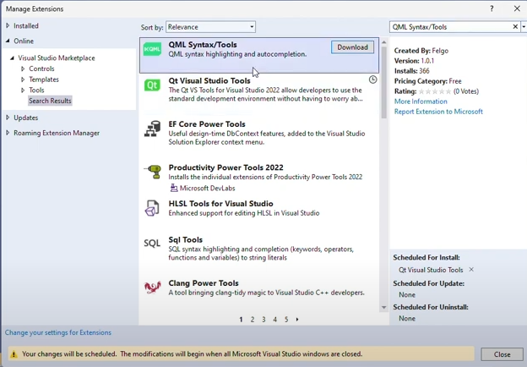

1. Then close the VS window. A small window “VSIX Installer” will appear, click on “Modify” and let it complete.

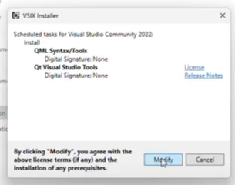

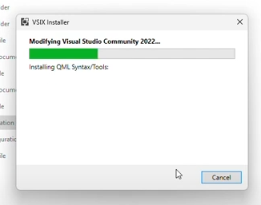

1. Then again launch VS and navigate to “Extensions”.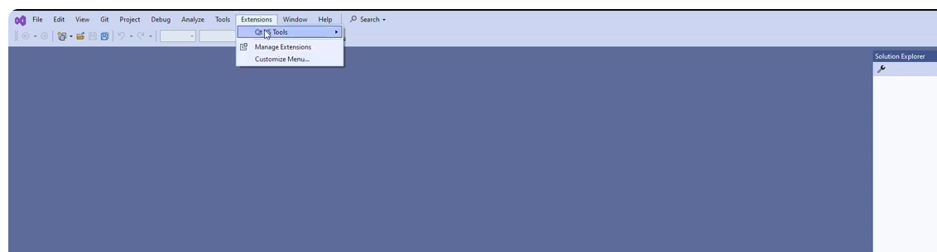
2. Then go to “Qt Versions”.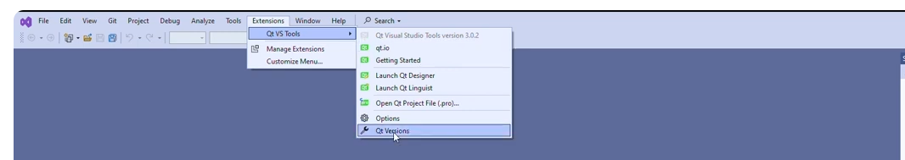
3. Then click on “Add new Qt version”.

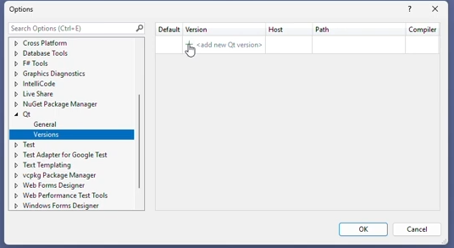

1. Then click on the Directory Icon.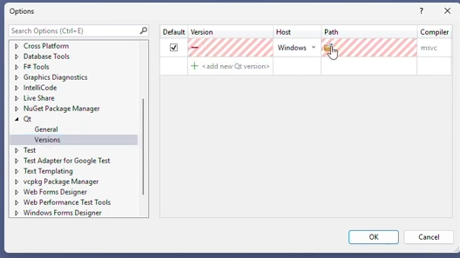
2. Once you click the directory icon, navigate to “qmake.exe” by following the path marked in red (Path depends on PC to PC because the installation path might be different)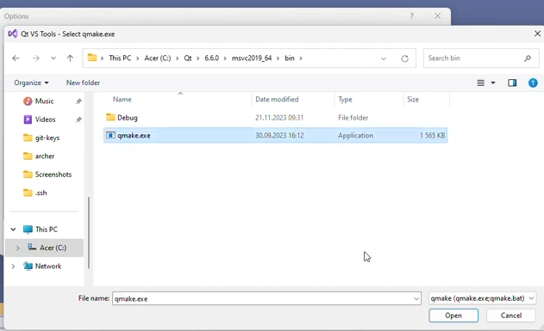
3. Then click on “OK”.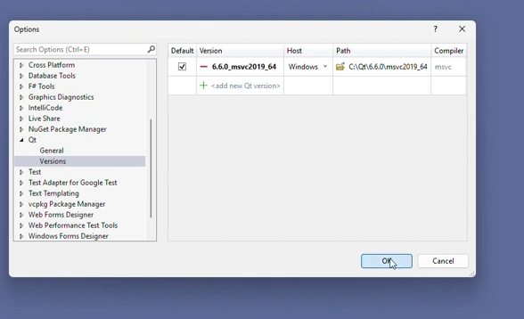
4. Then in VS window, ”Create a new Project” and then click on the project type you want to make.

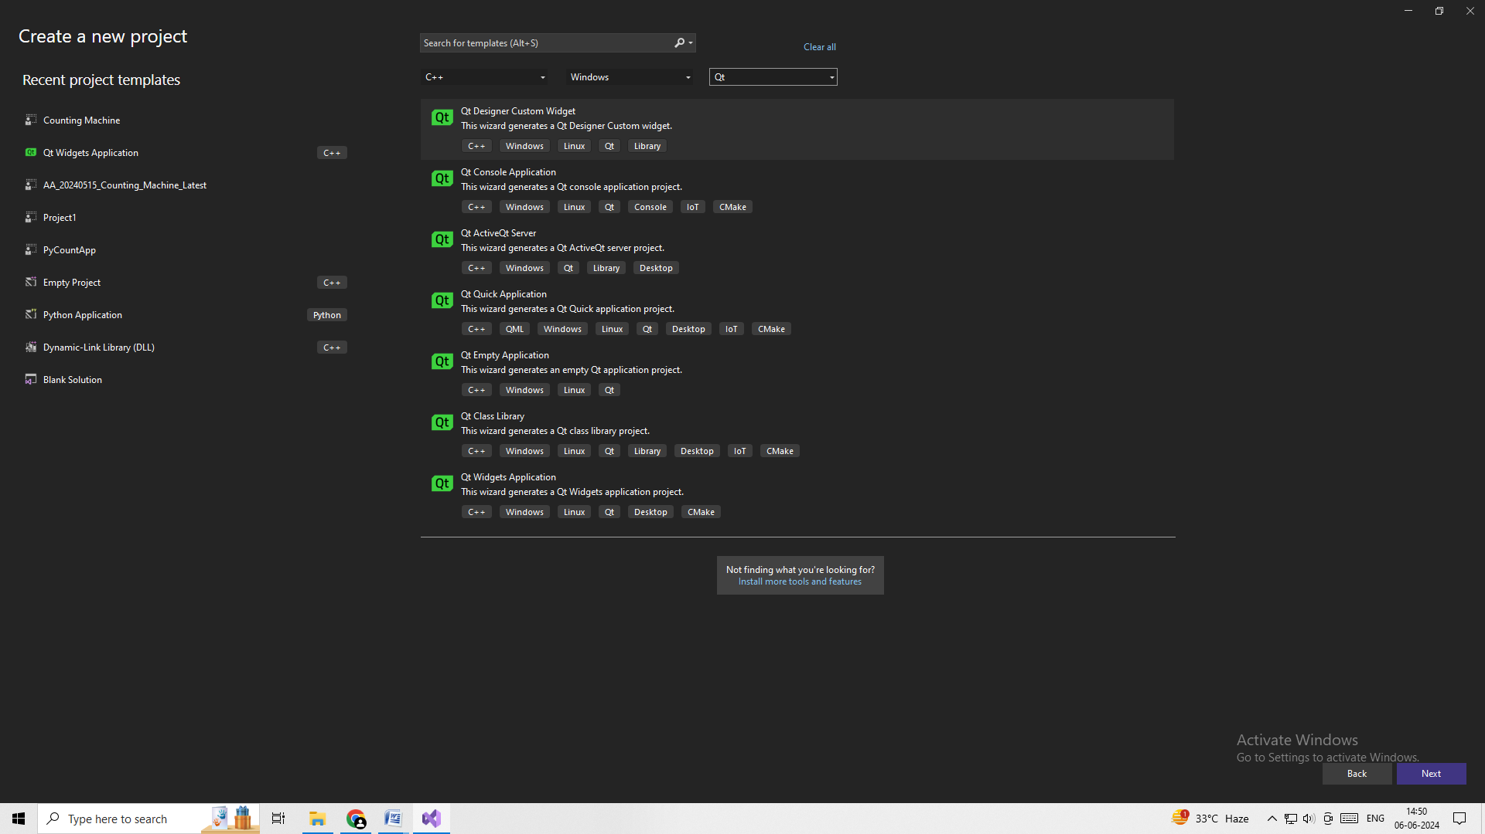

1. Then after entering the project name and selecting the saving directory of the project , you are set to write your programs.